Examine the concept of internet marketing?
Internet marketing refers to the strategies used to market products and services online and through other digital means. These can include a variety of online platforms, tools, and content delivery systems, such as:
- Website content and design
- Email marketing
- Social media
- Blogging
- Video/podcasting
- Online ads
- Sponsorships and paid promotions

How Internet Marketing Works
Internet marketing uses customers' online activity to connect them with a business by reaching them in a variety of places on the internet. The types of internet marketing a business uses will depend on the business model, types of products, target customers, budget, and more.

Website Content and Design
A business website allows customers to:
- Find your business online
- Learn your business's location or contact information
- Discover your products or services
- Sign up for your email list
- Request more information
- Make purchases

Why is Internet marketing important?
Internet marketing is important because it expands a business’s reach and allows them to connect with more leads interested in their business.
The importance of Internet marketing lies in that it best aligns with the way consumers prefer to discover and purchase products and services.

7 ways to use Internet marketing
You know the meaning of Internet marketing, but how can you use Internet marketing? A few ways:
- Build brand awareness
- Generate website traffic
- Attract qualified leads
- Nurture leads
- Convert leads (or drive sales)
- Reduce churn
- Improve customer satisfaction
Keep reading to learn how to use Internet marketing to grow your business.
Summarize the P.O.E.S.M Framework?
POEM stands for paid, owned, and earned media. While not a new framework, POEM represents a foundational approach to any a digital marketing strategy. POEM can be used to formulate and guide your digital marketing strategy and tactics, allowing you to capture more qualified leads and deliver better results.
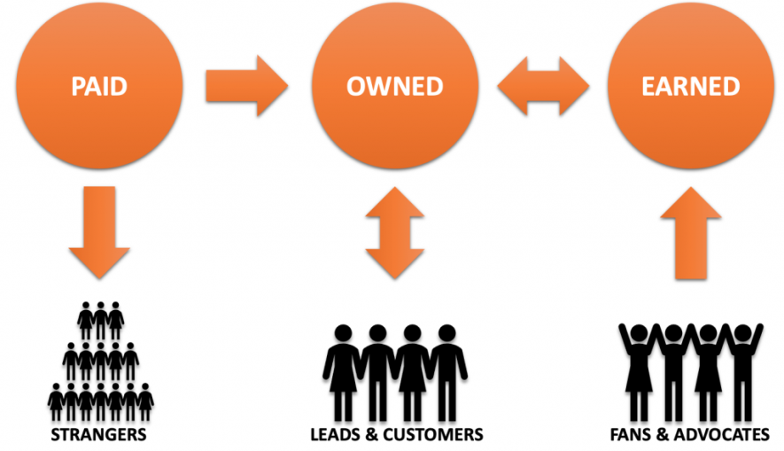
- Paid Media represents sponsored or paid ads that organizations run on various communication platforms. Digital examples include Facebook ads, Google ads, LinkedIn sponsored ads, banner or display ads, YouTube video ads, etc. However, offline paid media is also included, e.g., newspaper, radio, and magazine ads. In essence, paid media is any media where you pay to get exposure or access to an audience that you may not have an existing relationship with, i.e., “strangers”.
- Owned Media includes the content an organization creates and controls. Websites, e-newsletters, and blogs are good online examples. Offline examples could be a physical store, trade show booth, a paper newsletter, or even your employees (because they do represent your organization and your brand). The target audience for this type media is often prospective or existing customers.
- Earned Media represents content about your organization, services, or products, but created and distributed by others. Digital examples include shared posts, posts by customers about your organization, reviews, referrals, etc. Non-digital examples could include articles written by news organizations based on a press release or anyone who decides to write about your organization on their own. In essence, when you have earned the attention of your fans or advocates such that they “talk” about your brand, this is considered earned media.
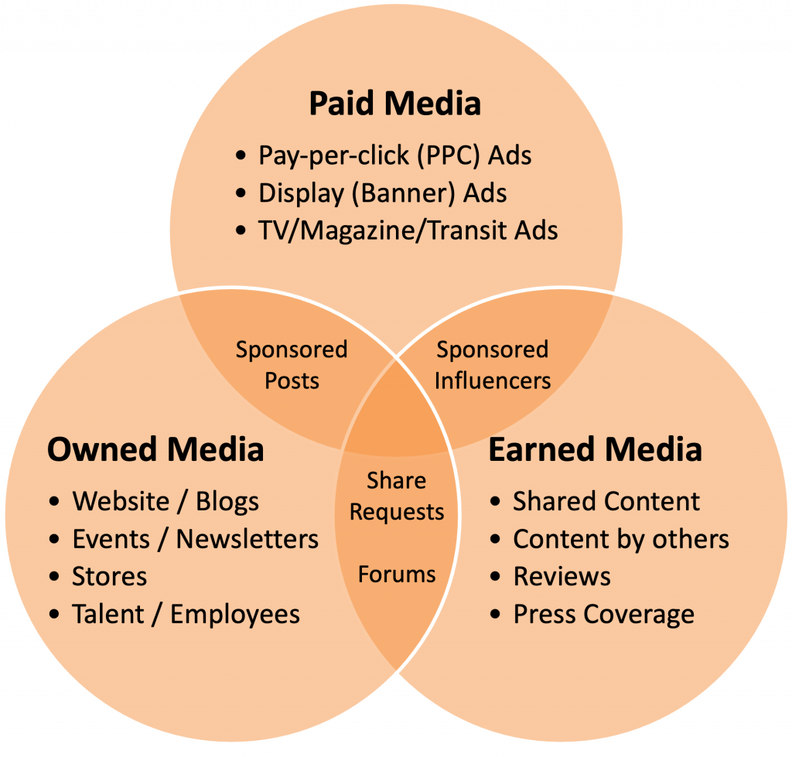

Explain Search Engine optimization?
Search engine optimization (SEO) is the art and science of getting pages to rank higher in search engines such as Google. Because search is one of the main ways in which people discover content online, ranking higher in search engines can lead to an increase in traffic to a website.
In Google and other search engines, the results page often features paid ads at the top of the page, followed by the regular results or what search marketers call the "organic search results". Traffic that comes via SEO is often referred to as "organic search traffic" to differentiate it from traffic that comes through paid search. Paid search is often referred to as search engine marketing (SEM) or pay-per-click (PPC).

Search engine optimization techniques
Understanding how search engines work is only the first step of the process in improving a site's search rankings. Actually improving a site's rank involves leveraging various SEO techniques to optimize the site for search:
- Keyword research - Keyword research is often the starting point for SEO and involves looking at what keywords a site is already ranking for, what keywords competitors rank for, and what other keywords potential customers are searching for. Identifying the terms that searchers use in Google search and other search engines provide direction on what existing content can be optimized and what new content can be created.
- Content marketing - Once potential keywords are identified, content marketing comes into play. This can be updating existing content or creating brand new pieces of content. Because Google and other search engines place a premium on high-quality content, it's important to research what content is already out there and create a compelling piece of content that provides a positive user experience and has a chance of ranking higher in the search engine results. Good content also has a greater chance of being shared on social media and attracting links.
- Link building - Because links from external websites (called "backlinks" in SEO parlance) are one of the core ranking factors in Google and other major search engines, obtaining high-quality backlinks is one of the main levers that SEO has. This can involve promoting good content, reaching out to other websites and building relationships with webmasters, submitting websites to relevant web directories, and getting press to attract links from other websites.
- On-page optimization - In addition to off-page factors such as links, improving the actual structure of the page can have tremendous benefits for SEO, and is a factor that is entirely in the control of the webmaster. Common on-page optimization techniques include optimizing the URL of the page to incorporate keywords, updating the title tag of the page to use relevant search terms, and using the alt attribute to describe images. Updating a page's meta tags (such as the meta description tag) can also be beneficial-- these tags don't have a direct impact on search rankings, but can increase click-through rate from the SERPs.
- Site architecture optimization - External links are not the only thing that matters for SEO, internal links (the links within one's own website) play a large role in SEO as well. Thus a search engine optimizer can improve a site's SEO by making sure key pages are being linked to and that relevant anchor text is being used in those links to help improve a page's relevance for specific terms. Creating an XML sitemap can also be a good way for larger pages to help search engines discover and crawl all of the site's pages.
- Semantic markup - Another SEO strategy that SEO experts utilize is optimizing a website's semantic markup. Semantic markup (such as Schema.org) is used to describe the meaning behind the content on a page, such as helping to identify who the author of a piece of content is or the topic and type of content on a page. Using semantic markup can help with getting rich snippets displayed in the search results page, such as extra text, review stars and even images. Rich snippets in the SERPs doesn't have an impact on search rankings, but can improve CTR from search, resulting in an increase in organic traffic.

Top SEO tools
As a fairly technical discipline, there are many tools and software that SEO relies on to help with optimizing websites. Below are some commonly used free and paid tools:
- Google Search Console - Google Search Console (formerly known as "Google Webmaster Tools") is a free tool provided by Google, and is a standard tool in the SEO's toolkit. GSC provides rankings and traffic reports for top keywords and pages, and can help identify and fix on-site technical issues.
- Google Ads Keyword Planner - Keyword Planner is another free tool provided by Google, as part of their Google Ads product. Even though it is designed for paid search, it can be a great tool to use for SEO since it provides keyword suggestions and keyword search volume, which can be helpful when doing keyword research.
- Backlink analysis tools - There are a number of link analysis tools out there, the two primary ones being AHREFs and Majestic. Backlink analysis tools allow users to analyze which websites are linking to their own website, or the websites of competitors, and can be used to find new links during link building.
- SEO platforms - There are many different SEO platforms that bring together many of the tools that SEO needs to optimize sites. Some of the most popular include Moz, BrightEdge, Searchmetrics and Linkdex. These platforms track keyword rankings, help with keyword research, identify on-page and off-page SEO opportunities, and many other tasks related to SEO.
- Social media - Most social media sites don't have a direct impact on SEO, but they can be a good tool for networking with other webmasters and building relationships that can lead to link building and guest posting opportunities.
Summarize about Email Marketing
Email marketing is the act of sending a commercial message, typically to a group of people, using email. In its broadest sense, every email sent to a potential or current customer could be considered email marketing. It involves using email to send advertisements, request business, or solicit sales or donations. Email marketing strategies commonly seek to achieve one or more of three primary objectives, to build loyalty, trust, or brand awareness. The term usually refers to sending email messages with the purpose of enhancing a merchant's relationship with current or previous customers, encouraging customer loyalty and repeat business, acquiring new customers or convincing current customers to purchase something immediately, and sharing third-party ads.

Why email marketing is important
Email marketing is one of the most lucrative sales tools for promoting your brand and generating leads. Let’s take a look at its benefits:
- It’s productive. Email marketing has an average ROI of $42 for every dollar spent.
- It beats social media in customer acquisition, bringing 40 times more new users than Facebook and Twitter combined.
- It’s extremely affordable. Your only out-of-pocket expense will be purchasing email marketing software. After that, you can send as many emails as you want. What is more, many email marketing services offer free plans for you to try their features.
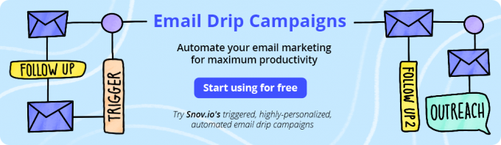

Advantages of email marketing
The benefits of email marketing include:
- Cost- effective - the costs of email marketing can be much lower than many other forms of marketing. There are no advertising fees, printing or media space costs.
- Permission-based - your marketing list will be made up of people who have actively chosen to receive email communications from you. Customers who are genuinely interested in your products and/or services are more likely to engage with your business.
- Flexible design - you can send plain text, graphics or attach files - whichever suits your message best. A choice of design options gives you scope to convey your business branding.
- Scalable - email marketing can be used to reach large audiences or smaller targeted lists.
- Personalisation and segmentation - with email marketing you can personalise messages. You can also segment your marketing list, so that your customers receive messages from you that they are interested in - this will help boost their engagement with you.
- Shareable - it's easy for people to forward and share your email content, building your reputation by word-of-mouth or viral marketing. This may help influence new customers to become followers of your brand.
- Conversions and increased sales - if you have a new promotion people can click on links and follow your call-to-action immediately. Email marketing is also effective at every stage of the buying process. For example, you can influence someone to choose your product, nurture the customer relationship post-transaction and also encourage future purchases.
- Measurable - you can evaluate the success of a campaign by using web analytics software. You can easily test different copy, subject lines and designs to see which is most effective. This allows you to optimise future campaigns.
- Benchmark - you can compare your results against others in your industry. There are many free email marketing benchmarking reports available - you will find these by searching online. Benchmarking data can help you to evaluate and prioritise improvement opportunities.
- Test before you send - A/B testing of subject lines, calls-to-action, personalisation, email copy, images or messages ensure your email content is as effective as it can be before you send it.
- Less intrusive - unlike telephone marketing, recipients can read your message at a time that suits them. Customers can also update their preferences if they would like to receive different messages from you or unsubscribe if they feel they no longer want to receive your email communications.
- Environmentally-friendly - email marketing is better for the environment than direct marketing by postal mail because nothing is printed.
- Time-saving - through automation you can trigger emails to be sent to customers based on an action they have performed on your website - eg. send a welcome email when a user signs up to your website, or issue an email offering a discount incentive if user abandons an online shopping cart. Once you have developed a template you can reuse for numerous email campaigns.
- Real-time marketing - through email marketing you can connect with customers in real-time. Using automated triggers, such as website activity, recent purchase or shopping cart abandonment, you can reach the right audience, at the right time, in the right place and with the right offer.
Classify the types of online advertising?
Online advertising, also known as web advertising or internet advertising, is a marketing strategy that uses the Internet as a channel for sending promotional messages to consumers. The 8 main types of online ads include product listing ads, display ads, demand-side platform ads, affiliate ads, native ads, social media ads, video ads, and email ads.

While online advertising is a highly cost-effective way to attract customers to your site, if you’re just getting started, you can get overwhelmed by the overload of options. That’s why we’ve decided to break down every kind of advertising in this article - from how they work to their unique advantages. Read on to figure out what kind of online ads are best suited for your business.
- Google Search Ads
- PPC Ads
- Bing Ads
- Facebook Ads
- Twitter Ads
- Tumblr Ads
- Banner Ads
- Google Display Ads
- Retargeting Ads
- Reddit Ads
- Mobile Ads
- In-Game Ads
- In-App Ads
- Email Ads
- Gmail Ads
- Video Ads
- YouTube Ads
- Pinterest Ads
- Instagram Ads
- TV Ads
- Newspaper Ads
- Radio Ads
- Urban Ads

Display Advertising
Display advertising is the use of web banners or banner ads placed on a third-party website or blog to drive traffic to a corporate website and increase product awareness. These banners consist of static or animated images, as well as interactive media including audio and video. Display advertising uses demographic and geographic targeting – capturing users' cookie and browser history to determine demographics, location, and interests – to target appropriate ads to those browsers

Affiliate marketing
Affiliate marketing is a form of online advertising where advertisers place campaigns with a potentially large number of publishers, who are only paid media fees when the advertiser receives web traffic. Web traffic is usually based on a call-to-action or measurable campaign result such as a submitted web form or sale. Today, this is usually accomplished through contracting with an affiliate network.

Social Network Advertising
Social network advertising is a form of online advertising found on social networking sites such as Facebook. Advertising on social media networks can take the form of direct display ads purchased on social networks, self-serve advertising through internal ad networks, and ad serving on social network applications through special social network application advertising networks.

Search Engine Marketing (SEM)
Search engine marketing is a form of marketing that seeks to promote websites by increasing their visibility in search engine result pages (SERPs). SEM tactics include paid placement, contextual advertising, and paid inclusion, or free search engine optimization techniques to drive placement of their ads. Advertisers pay each time users click on their listing and are redirected to their website, rather than for the ad itself. This system allows brands to refine searches and gain information about their market.

Mobile Advertising
Cell phone advertising is the ability for organizations and individuals to advertise their product or service over mobile devices. Mobile advertising is generally carried out via text messages or applications. The obvious benefit of mobile advertising for brands is that mobile devices such as smartphones are usually close to the owner throughout the day. This presents a cost-effective way for brands to deliver targeted advertisements across mobile platforms on a daily basis. Technologies such as location-based advertising also give marketers the ability to deliver ads in close proximity to the physical location of a consumer. Although advertisements appear on a small mobile interface, mobile advertisers have the ability to deliver personalized, and thus effective, messaging.

Why is online marketing preferred more than offline marketing

Difference between online marketing and offline marketing :
S. No. | Online marketing | Offline marketing
1. | Online marketing is generally focus on content. | Offline marketing is generally focus on product.
2. | Online marketing includes third party like media, web content, search e-mail, social media. | Offline marketing includes mass media, phone center, telephone.
3. | Online marketing communicates customers with e-mails, chat, social media. | Offline marketing communicates with customer with their mobile number and staff.
4. | Target audience met at one place. | Target audience is scattered.
5. | It is cost effective. | It is high marketing cost.
6. | It helps in directly reaches out to the professionals of the industry and market. | It does not directly reaches out to the professionals due to some barriers.
7. | Prospective buyer cannot visible. | It directly visible to their prospective buyer.
8. | Less people to manage. | Large people to manage.
9. | The tools such as Google webmaster tools, AdWords information center, and other tools, can be used to check view rate, conversion rate, and overall advertising success of internet marketing. | Here, is the challenging task of measuring the success of print, radio, and television advertising because it is uncertain whether an audience will make a purchase or not.
10. | Using Content marketing tactics your content can reach to a worldwide audience. Every day, content reaches thousands of individuals, boosting your influence and coverage. | This may not be possible with offline marketing.
11. | In online marketing, you can sell a product all across the world without even opening local stores. No need to keep large stocks. It ensures global exposure. | Offline promotions have their own limitations. It never ensures maximum exposure.
12. | Internet marketing has no time constraints. Customers can visit your website at any time and purchase your items or services. | Here, you can only expect sales or clients once your store is open.
13. | Online marketing helps you in growing your business by targeting a specific group of customers with a specific offer. You can also target a certain group of people for promotions. | It is quite a challenge to implement these types of strategies in offline scenarios. These tactics can only be used by small businesses to retain clients.
14. | Various ways of Online Marketing  - Affiliate marketing:  - Social media marketing  - Word of mouth marketing  - Content Marketing  - Search engine optimization  - Email Marketing  - Influencer marketing  - Brand marketing  - Cause marketing | Various ways of Offline Marketing  - Billboard ads  - Business cards  - Direct mail  - Telemarketing  - Print ads

Elaborate the Impact of E-mail marketing?
- Flexible
You can use different types of content, from plain text to videos, infographics, etc. You can also attach files. Therefore, emails give you countless opportunities to experiment with design and content.
- Cost-effective
Email marketing can be much cheaper than other types of marketing. There’s no need to pay for media space or printing, and there are no advertising fees.
- Scalable
You can use email marketing with both short & well-targeted lists, and when working with large audiences.
- Permission-based
Your email list consists of people who decided that they want to receive emails from you. They are already interested in your brand.
- Shareable
The email content is easy to share so it also gives you opportunities for viral and word-of-mouth marketing.
- Measurable
You can use different types of analytics software to measure the success of your campaign. For instance, you can test different calls to action, subject lines, copies, and images to determine the most effective content. This way, you can improve your campaigns with time.
- Less intrusive
Recipients can read your emails when they want. Unlike phone calls, emails don’t interrupt people. Besides, you can personalize emails and adjust them to a particular recipient’s needs and preferences.
- Real-time
Thanks to automated triggers like a purchase, website activity, or shopping cart abandonment, you can connect with your customers in real-time. You can make just the right offer at the right time.
Discuss the scope and growth of direct marketing?
Direct marketing is the best way to generate leads for your business, generate traffic, and to increase the awareness of your brand. The scope of direct marketing is the most powerful when it’s used with customer segments where past behavior can be used to predict future behavior. Since direct marketing is used to stimulate immediate behavior that can be recorded, tracked, analyzed, and stored for future retrieval and use, the scope of direct marketing can be used to help grow your business and spread recognition of your brand.

ROI Based Campaign
When planning your next direct marketing campaign, it’s much better to focus on generating higher ROI than more savings. As a growing business, it might be more appealing to launch a direct marketing campaign that focuses on cost savings rather than spending more money to increase your ROI. It’s best, though, to always keep the big picture in mind and don’t let initial campaign prices deter you from what’s really important, launching a successful campaign that increases ROI.

Simplify Your Message
One of the best direct marketing techniques to adopt is to keep your direct marketing campaign message short, simple, and to the point. If it takes too long to read your message, customers won’t know what your business has to offer or even remember your brand. Your message should not only be short, simple, and to the point but it should also be concise and uniform across all channels you have the message running on.

Set Realistic Expectations
Whatever direct marketing strategies you use for your campaign, it’s important to be able to determine the success of the campaign. It’s important to set direct marketing campaign goals ahead of time but what’s even more important is setting realistic goals. Without realistic expectations, you won’t have a good understanding of how well your direct marketing campaign is performing which will give you a skewed impression of what’s working for your business and what isn’t.

Target Your Audience
It should be no surprise that one of the most important direct marketing techniques is to target your audience with your messaging. It doesn’t make any sense to spend time and money reaching out to people who have no use for your product or services so knowing who your customers are is the only way to learn the best ways to reach and appeal to them. It’s important that any direct marketing campaign you launch is relevant to your target audience and aligns with their wants and needs.

Strong Call to Action
Of all the direct marketing strategies you can use to produce a successful direct marketing campaign, the most important is including a strong call to action. Effective calls to actions aren’t subtle, but instead are strongly worded and quickly communicate how the potential customer will benefit from your business. A strong call to action is clear about what it wants the audience member to do and isn’t shy about asking them to do it.
List the stages of search engine optimization?Explian
Search engine optimization (SEO) refers to techniques that help your website rank higher in organic (or “natural”) search results, thus making your website more visible to people who are looking for your product or service via search engines. SEO is part of the broader topic of Search Engine Marketing (SEM), a term used to describe all marketing strategies for search. SEM entails both organic and paid search. With paid search, you can pay to list your website on a search engine so that your website shows up when someone types in a specific keyword or phrase. Organic and paid listings both appear on the search engine, but they are displayed in different locations on the page.
  - Content on your website: When indexing pages, the search engine bots scan each page of your website, looking for clues about what topics your website covers and scanning your website‟s back-end code for certain tags, descriptions, and instructions. 2. Who’s linking to you: As the search engine bots scan webpages for indexing, they also look for links from other websites. The more inbound links a website has, the more influence or authority it has. Essentially, every inbound link counts as a vote for that website‟s content. Also, each Tweet this eBook! 8 ⏐ Introduction to Search Engine Optimization inbound link holds different weight. For instance, a link from a highly authoritative website like The New York Times (nytimes.com) will give a website a bigger boost than a link from a small blog site. This boost is sometimes referred to as link juice.
A few factors that a search engine algorithm may consider when deciding what information to show in the SERP include: • Geographic location of the searcher • Historical performance of a listing (clicks, bounce rates, etc.) • Link quality (reciprocal vs. one-way) • Webpage content (keywords, tags, pictures) • Back end code or HTML of webpage • Link type (social media sharing, link from media outlet, blog, etc.)

Enumerate the concept of online public relation management?
Digital PR is the professional maintenance of a favorable online image by a company. A Digital PR agency promotes a company via online blogs, websites, and social media.
The goal of a Digital PR campaign is to increase online mentions, backlinks, and the brand of a company, all of which are even more critical to a brand’s success now compared to previous years. Digital marketing PR has grown in popularity as the Internet has become more popular. The rise of social media has also led to an increase in digital PR, as companies can use these platforms to reach a wider audience.
- Improves SEO rankings. Google was founded as a hypertextual search engine. Backlinks are a key component to how websites appear in search engine results pages. Generally speaking, the more relevant the links, the better the website will rank. Digital PR helps secure backlinks at scale.
- Grows website traffic. The premise of public relations is to secure editorial coverage of a company. This editorial coverage increases referrals and helps grow website traffic.
- Builds brand. A reputable third-party platform can help introduce a company to a new audience. A digital public relations strategy builds a business’s brand by increasing the online mentions of an organization.
- Generates leads. When website traffic increases, new leads tend to increase as well. Digital PR increases organic search traffic and referral traffic through SEO.
- Increases sales. Digital PR helps build the trust of a brand. When a consumer trusts a brand, they are more likely to buy.
Draw a format of online advertising? And discuss
Online advertising is any type of marketing message that shows up with the help of the Internet. That means it could appear in a web browser, search engine, on social media, on mobile devices, and even in email.
Savvy advertisers are increasingly making use of this forum for reaching consumers, for a number of reasons:
- It's relatively inexpensive
- It reaches a wide audience
- It can be tracked to measure success (or failure)
- It can be personalized for a target audience
Indeed, online advertising is only growing in scope, as new avenues for marketers pop up (think ads delivered through text message or marketing messages delivered to users in a certain area, known as geo-targeting). But, while some of the ads are less common or just gaining traction, there are plenty that we're exposed to multiple times every day. Let's take a look at some of the most popular types of online advertising.

Types of Online Advertising
Whether you're surfing the web or just checking your email, you can't really get away from advertisements delivered in a digital setting. Here are some of the most popular types.

Display Ads
Probably the oldest form of online ads, display ads, appear as everything from banners of all shapes and sizes to text ads relevant to the content of a page. You might find an AutoZone display ad on a popular car blog or a banner ad promoting the newest products at Sephora on a popular beauty or cosmetics blog.

Email Ads
Email ads are such a popular form of online marketing that many consumers don't even think about them being advertisements. Open your inbox and you're likely to see advertisements promoting new services from your cable provider, special offers on children's clothes from Macy's, or the latest cell phone gadget from Samsung or Apple. Email ads sometimes come in the form of coupons or newsletters.

Native Ads
Then there are native ads that are disguised in the form of a sponsored post: for example, Virgin Mobile doing a post titled ''6 Texts to Copy and Paste to Break Up With Your Significant Other'' on Buzzfeed, or in the form of an advertorial, an online (and sometimes print) ad designed to look like editorial content but promoting a product or service. Airbnb had a successful native ad placement with The New York Times, tracing the path of immigrants from other countries into the United States at Ellis Island. It is interesting and informative and advertises Airbnb in a discreet way with a small logo at the top.

Social Media Ads
Whether it's Facebook, Twitter, or YouTube, marketing messages are everywhere on social media platforms. From Facebook ads to sponsored tweets and ads that pop up between YouTube videos, social media is an effective place for marketers to reach their audience because we spend so much time scrolling through our newsfeed, commenting, liking, and sharing. A newer form of social media advertising are sponsored filters on apps like Snapchat that tie in a fun component, like a taco face filter, with a sponsorship by Taco Bell.
Discuss in detail about online marketing domains?

Online marketing is the effort to market products and services and build customer relationships over the internet. The four major online marketing domains are:

Business-to-Business: Businesses using online marketing to reach new business customers more effectively and obtain buying efficiencies in better prices. Tata Group’s B2B content marketing has the website – Tata.com. When a business grows so large and has numerable companies, Tata Group created a website umbrella where any person can learn about the brand in an easy manner.

Business-to-Consumer: Businesses selling goods and services online to final consumers. Tata Group has decided to stay off Facebook and communicate through LinkedIn and Twitter. Their communication across the two mediums is quite distinct. On Twitter, they have focused on informing readers about the latest news on Tata, but their communication on LinkedIn is more focused on their B2B audience.

Consumer-to-Consumer: Online exchanges of goods (Example: Ebay, Craigslist.com and information (blogs) between final consumers. Dell has a dozen or more blogs that facilitate a direct exchange with Dell customers about their technology. They might even encourage sponsored conversations by influential bloggers.

Consumer-to-Business: Online exchanges in which consumers search out sellers, learn about their offers, initiate purchases, and sometimes even drive transaction terms. At priceline.com, would-be buyers can bid for airline tickets, hotel rooms, rental cars, cruises and vacation packages, leaving the sellers to decide whether to accept their offers or not.
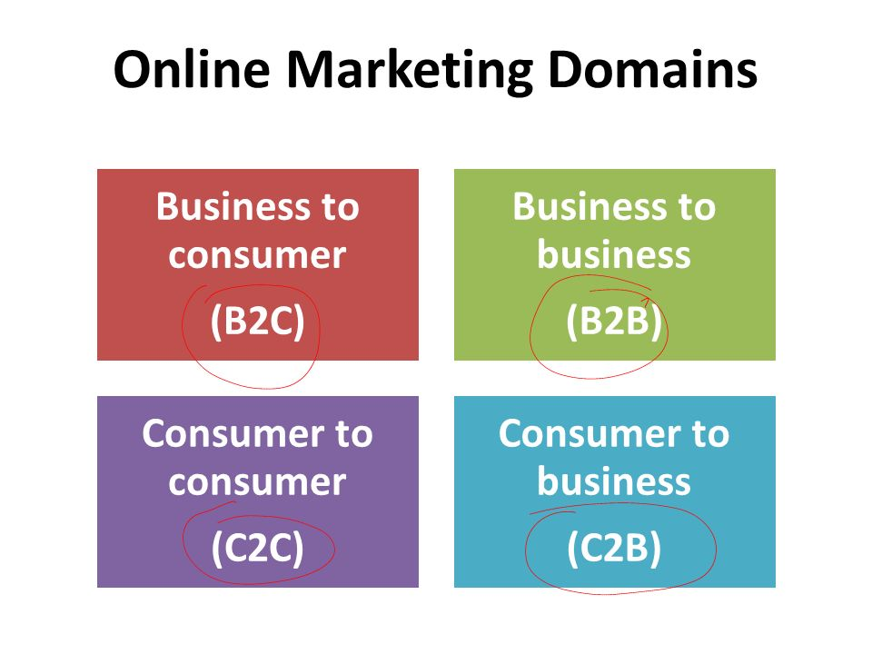

Elaborate what is meant by e-mail marketing and its types and strategies?

Email marketing is a direct marketing channel that lets businesses share new products, sales, and updates with customers on their contact list. Its high ROI makes it crucial to most businesses’ overall inbound strategy.

Types of marketing emails
Marketing emails can be promotional, informational, or serve a specific purpose in the buyer journey.

Promotional emails
Email marketing campaigns are used to promote special offers, new product releases, gated content like ebooks and webinars, and your brand at large. A campaign could consist of 3-10 emails sent over several days or weeks.
Promotional emails have a clear call-to-action — CTA, for short. The CTA represents the specific action you want the reader to take, whether it’s visiting a page on your website or using a coupon to make a purchase.

Informational emails
Newsletters: A newsletter, as the name suggests, shares news related to your business. Think: new milestones reached, new product capabilities, or featuring valuable content like case studies. Sent at regular intervals — weekly, bi-weekly, monthly — newsletters help maintain consistent touch points with your email subscribers.

Re-engagement emails
Another important type of marketing email is the re-engagement email. As the name suggests, re-engagement emails help reconnect with customers or subscribers who haven’t been active lately.

How to Create an Email Marketing Strategy

- Set email marketing goals
- Pick the necessary email marketing tools
- Determine the target audience
- Identify the appropriate list building tactics
- Divide your mailing list into segments
- Identify the types of emails to send
- Create a schedule for sending emails
- Format the email content
- Optimize your emails
- Conduct split-testing
- Monitor email performance reports

Set email marketing goals
Marketing emails serve to fulfill the following purposes:
- increase customer engagement
- raise loyalty
- maximize ROI
- maintain relationships with your clients
Marketers thus need to create emails that are in line with any of these or other desired goals.

Pick the necessary email marketing tools
Finding the right tools is the first step to setting up an email marketing strategy. A marketer needs an Email Service Provider (ESP) with an automation tool, among other useful features.
SendPulse allows you to create, organize, and send emails in a breeze. With Automation 360, marketers can follow up on their customers and send the right emails at the right time. For instance, you can set up welcome emails for onboarding new customers, abandoned cart emails to get customers to take action about the items they have left in the cart, and so forth. Register right now to launch your email marketing strategy with SendPulse.

Determine the target audience
Next, the marketer needs to build their email subscriber list. To do this, you have to identify the target audience your company serves. Case in point, if a specific business deals with baby clothes, then its target audience primarily comprises mothers-to-be. Thus, it makes sense to use conventional means to get the email addresses of this demographic.

Identify the appropriate list building tactics
An excellent way of building mailing lists is through subscriptions. With SendPulse, you can add subscription forms to your site and collect quality subscribers who are ready to hear from your brand. You can embed subscription forms on high-traffic sections of your website.

Divide your mailing list into segments
Segmenting is an effective tactic that allows you to send highly targeted email campaigns. With SendPulse, marketers can segment their mailing lists based on location, gender, occupation, age, behavior, etc. In turn, you can be sure that you are delivering appropriate and customized messages that appeal to customers.

Identify the types of emails to send
There’s a great variety of different emails that marketers send. The choice of email style depends on the aim of each specific campaign. For example, if a user has just joined your mailing list, send them a welcome email. This is a great chance to explain the benefits of working with you. If clients have added some items to their shopping cart and didn’t buy them, send them an abandoned cart email to increase sales. Discover more about email campaign types.

Create a schedule for sending emails
To ensure that subscribers read your promotional emails, find out the best time for sending emails. It is, therefore, necessary to experiment and determine the time when subscribers are most engaged. A/B testing proves useful.

Format the email content
For email marketing to be a success, messages in promotional emails should be presented perfectly. Marketers should choose formats, fonts, and text sizes depending on the type of emails that they are creating. With SendPulse, you can use a drag-and-drop editor to create beautiful email templates that are customized to match your brand.

Optimize your emails
A 2017 study by Adestra concluded that 83.8 percent of mobile device owners open emails with these devices. It, therefore, makes sense to optimize email content for mobile to reach this audience. Some of the ways for assuring that email content is mobile-friendly include:
- Creating short subject lines.
- Limiting emails to a width of 600px.
- Using single-column templates.
- Displaying small images.
- Writing distinct CTAs.
- Testing on multiple mobile devices.
- Avoiding menu bars.
- Using a large font size (ideally 13-14 pixels).

Conduct split-testing
With A/B testing, marketers can determine what copy of their email works best by swapping out different aspects of their email, such as subject lines (the most popular option), images, CTAs, headlines, offers, and so forth.

Monitor email performance reports
Adjusting your email strategy based on reports and feedback that you have gathered is the last step for developing an email marketing strategy. SendPulse provides users with a set of analytics that aids in gauging the effectiveness of email campaigns. Track email open rate, unsubscribe rate, click-through rates, email deliveries, email bounces, spam complaints, and more.
What are the concept and role of internet in marketing?

7 reasons why Internet marketing matters
With the growth of technology, it’s crucial that you have an effective Internet marketing plan in place. Internet marketing helps you continue to grow your business. Here are seven reasons why marketing is so important.

1. Your customers are online
Internet marketing is so important because your customers are online. Considering that over 4.2 billion people are on the Internet, it’s a great opportunity for you to reach leads that are looking for your business. There are billions of people online just waiting to find your company.
People use the Internet to find all types of information. They’re constantly conducting searches to find relevant information about businesses, products, and services. By investing in Internet marketing, you’re helping your company reach those interested leads.
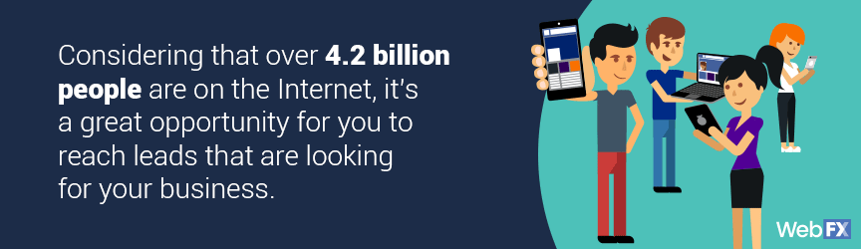
.

2. It create two-way communication
With traditional advertising, the communication is one-way. You create a TV ad or print ad in a newspaper, and that’s it. You wait and hope that your audience will see your ad and visit your business.

3. It personalizes your audience’s experience
As we stated previously, your audience wants to feel like they matter to your business. They don’t want to just be another number. Effective Internet marketing creates a custom experience for each member in the audience.

4. It allows you to drive quality traffic
One of the biggest hurdles with traditional advertising is obtaining interested leads.
When you use traditional advertising, you don’t know how many valuable leads you will reach. Your advertisements appear in front of interested and uninterested leads, which makes it difficult to drive an abundance of quality traffic.

5. It increases your business’s visibility
When you want more people to check out your business, you must increase your business’s visibility. It can be challenging to do this through offline tactics because you don’t have much control over who sees your marketing materials.
With online marketing, you expose your business to hundreds of people.
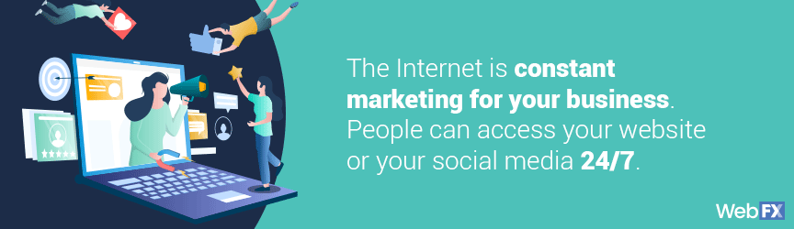

6. It allows you to multitask
The importance of online marketing also includes its ability to run multiple campaigns at once. The Internet makes it easy for you to take on a high level of customers and provide them with a quality experience.

7. Your competitors are doing it
If you want to remain in competition with your competitors, you must invest in Internet marketing. Your competitors are already investing in different Internet marketing methods and working to obtain new leads.
CASE STUDY
Our plan of action to improve their PPC campaign was made up of three important initiatives: (1) Implement the most efficient structure for the account, (2) Design and implement optimized landing pages (3) create a disciplined process for managing the campaign that results in ongoing improvements.

1. Implement account structure
Our first step was to learn the ins and outs of the client’s business. We began by evaluating their services, their target audience, the industries they serve, and their competitors.
We started by conducting thorough research using the Google Keywords tool and identified the most suitable keywords for their campaign. The best keywords we found were niche keywords for specific industries, including SaaS and technology. Additionally, we used geographical keywords for metropolitan areas like San Francisco, Chicago, and New York City.
After evaluating the report from their old campaigns, we identified some excellent new negative and regular keywords. We also implemented some keywords we found using SpyFu, a tool that allows you to peek at your competitor’s keywords. Then, it was time to develop a solid account structure.
Additionally, we implemented:
- A tagline below the logo in order to emphasize Sales Recruiting
- A phone number that integrates with Google call tracking. This enabled us to track all phone calls that were made from the landing page.
- Legitimate customer testimonials, which is an excellent way to establish trust between you and the viewer.
- A strategically placed form with limited fields.
- A clear and captivating call to action.

Continuous optimization and testing
Campaigns should always be A/B tested to ensure that they are performing to their best ability. In this case, our A/B testing proved that the adjustments we made were outperforming the old campaign by a lanslide. However, there were still a few adjustments necessary.
A/B Testing
For each of the ad groups receiving the most traffic, we began with two ad groups. After some close monitoring and A/B testing, we decided upon a winner. We then used that ad to craft another version, tested this against the original, and continued this process in order to achieve the best click-through rates.
Our new campaign performed remarkably well—just take a look at the table below to see the huge difference in the cost-per-conversion and the conversion rate:

